**Assignment 3**

**Preparation Setup**

1. Create region in a new project and set its position and resolution as bellows.

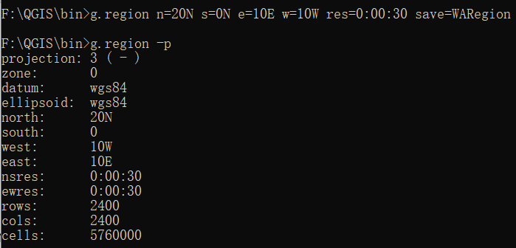

1. Add “mea” raster data into GRASS panel using r.external.

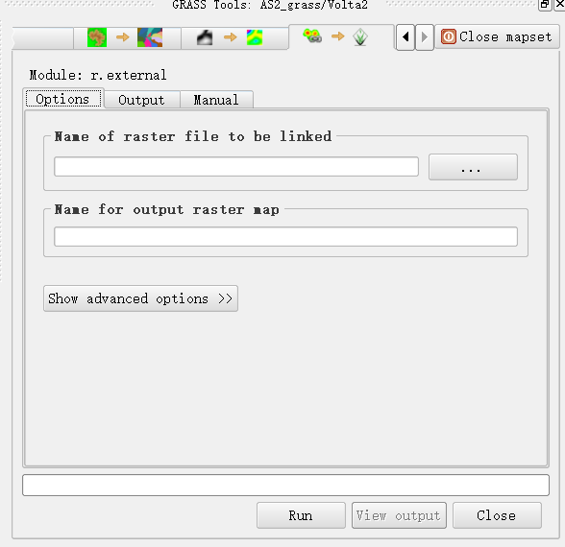

1. In order to eliminate the edges caused by different limits of raster files, r.patch method is used to patch these raster data together and discard those data outside of the boundary.

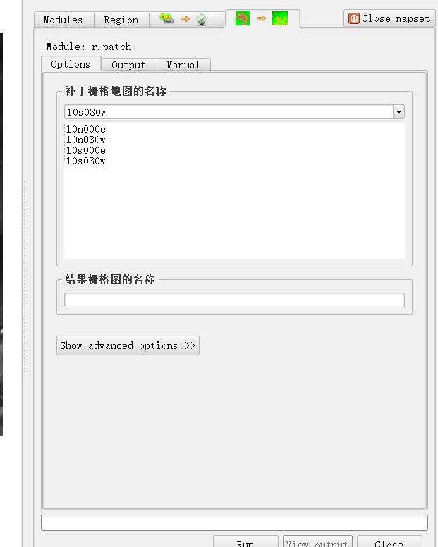

**Task 1. Terrain analysis**

1. Symbolize the data to get a better visualization. Above multiple colormaps of displaying, color palette for Shuttle Radar Topography Mission Elevation is utilized eventually.

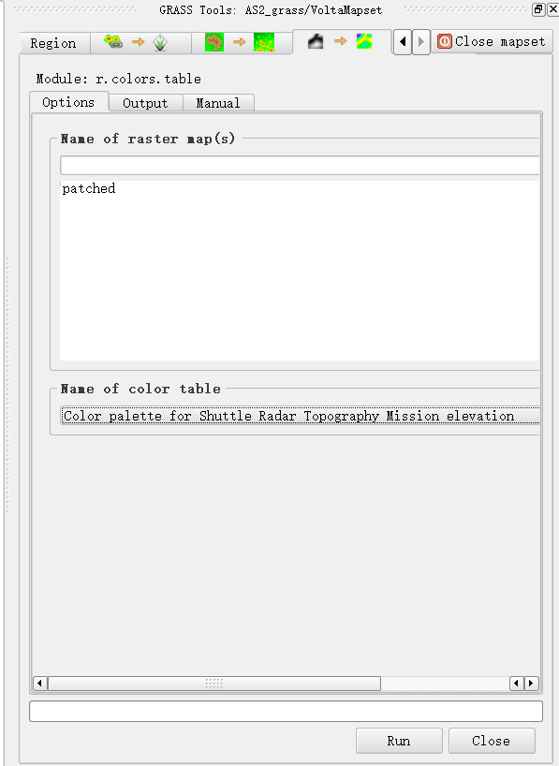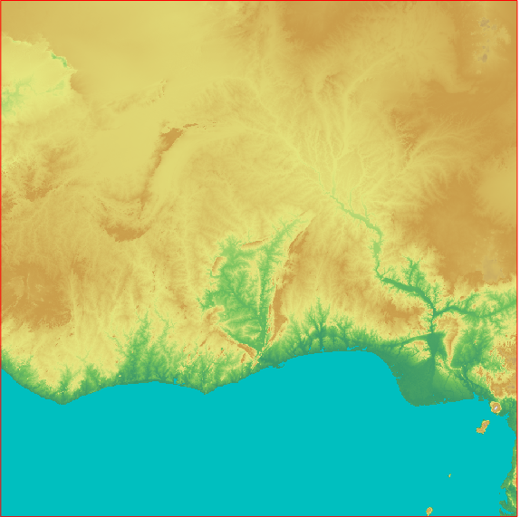

1. Create a shaded basin by applying r.relief method, and shift DEM up, set its transparency to 46% so that it looks like a 3D map.

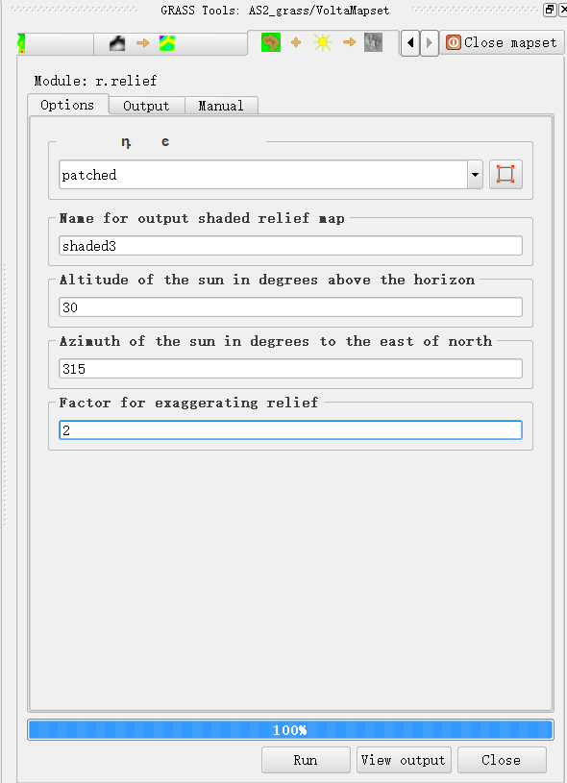

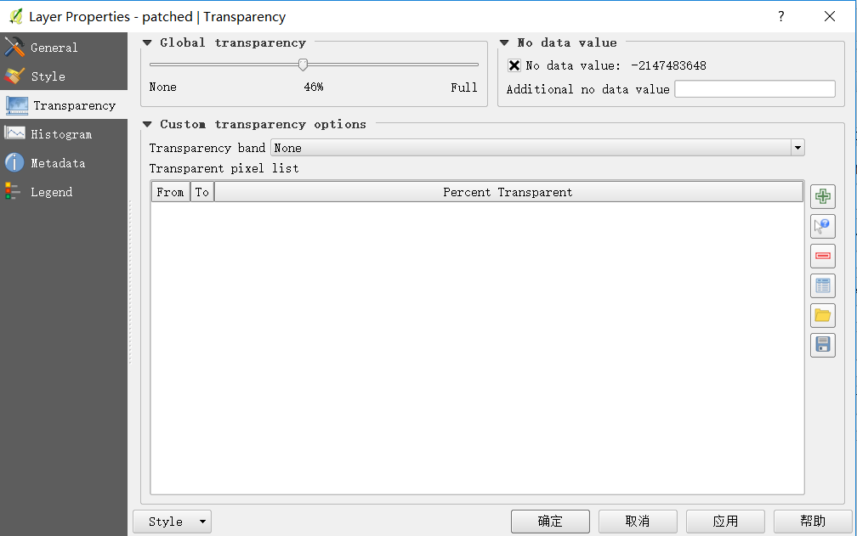

**Map:**

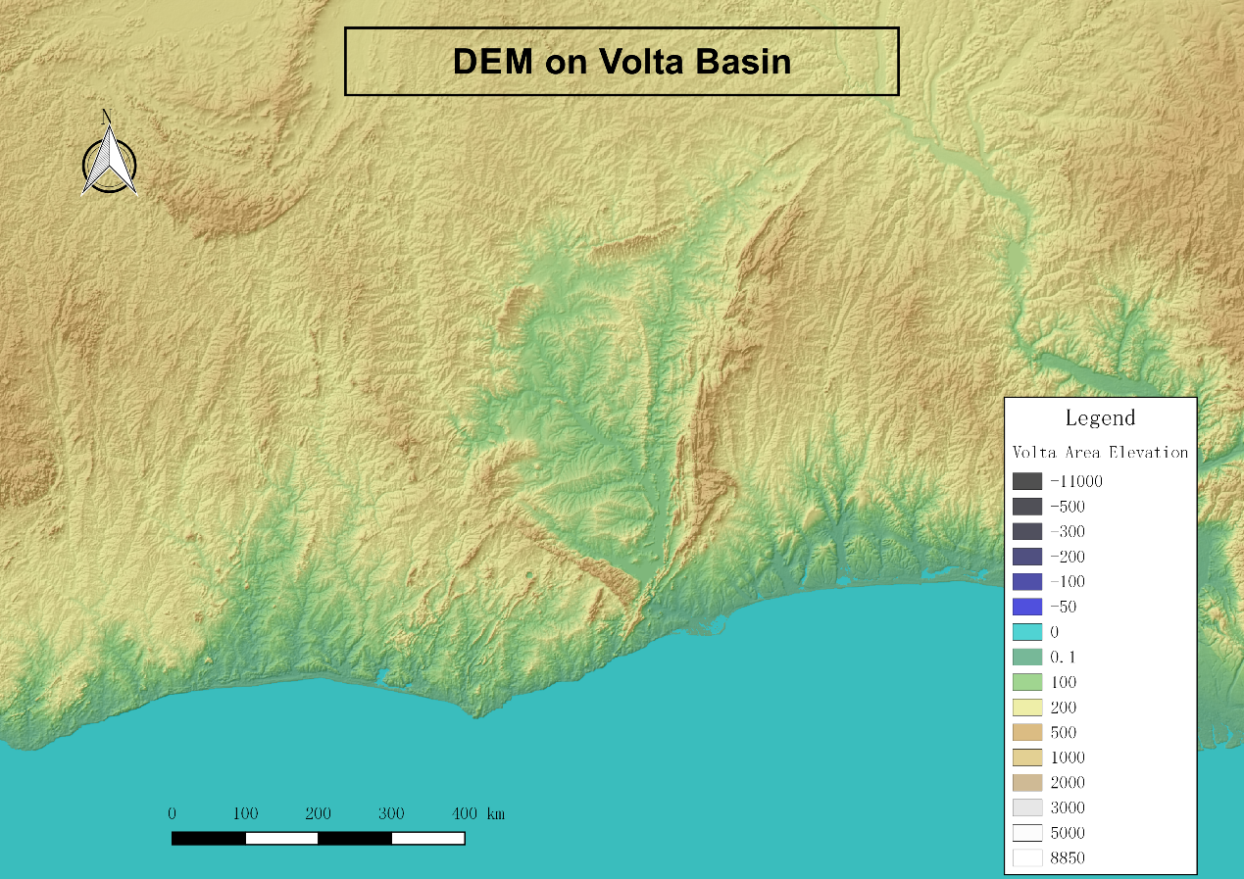

**Task 2. Outline Volta Basin**

1. Map calculator(syntax shown below)

In terms of reducing cumbersome calculation, we specify large region into our focus by typing such syntax in QGIS command and save as “VoltaRegion”

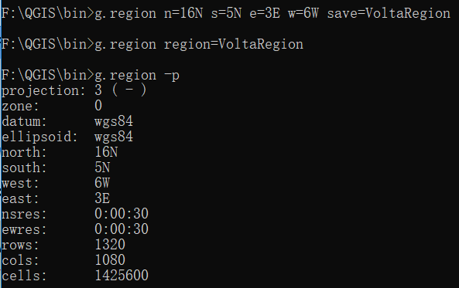

1. Further, map calculator is introduced to clip DEM on land as conditionally put Volta basion as mask.

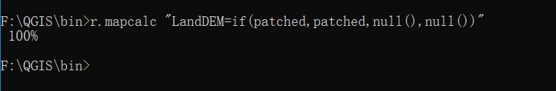

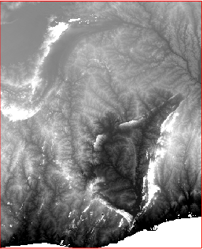

1. Generate flow accumulation raster and drainage direction raster file with the r.watershed method in the hydrologic model by QGIS shell.

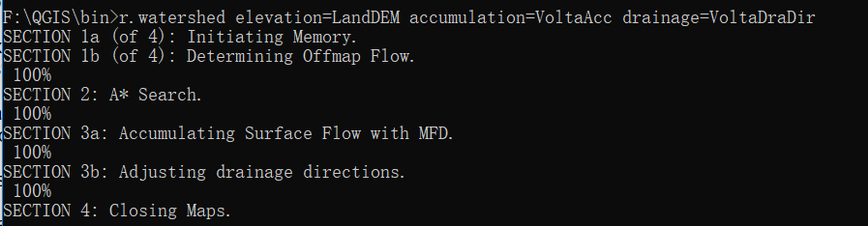

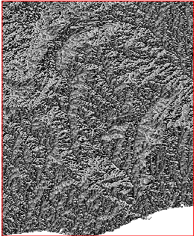 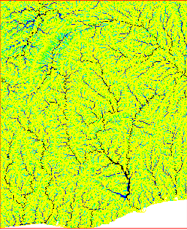

Drainage direction Flow accumulation

1. Delineate sub-basins inside Volta, “r.water.out” method is utilized. The coordinates of outlet points are picked up firstly as input features, which represent the ultimate outflow into the ocean.

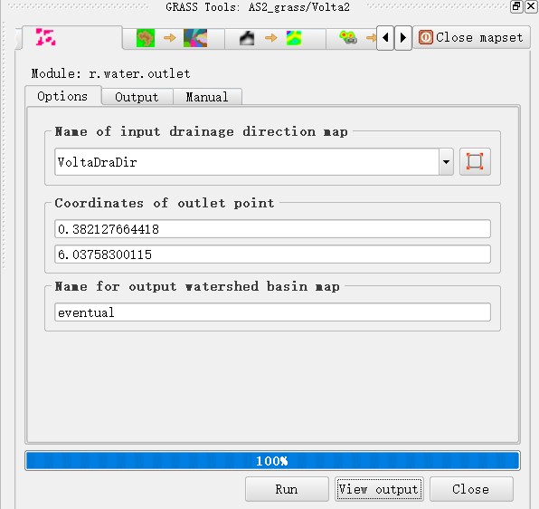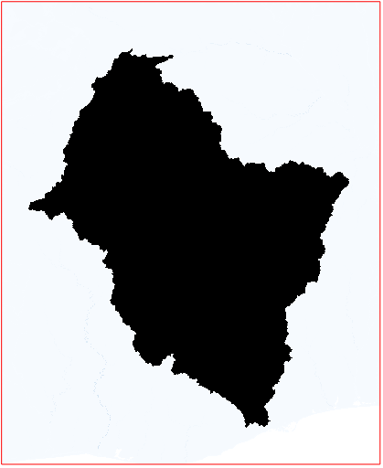

1. Convert raster data of Volta Basin outline to vector with r.to.vect.area method and add into the panel, leaving its solid boundary only instead of showing frame.

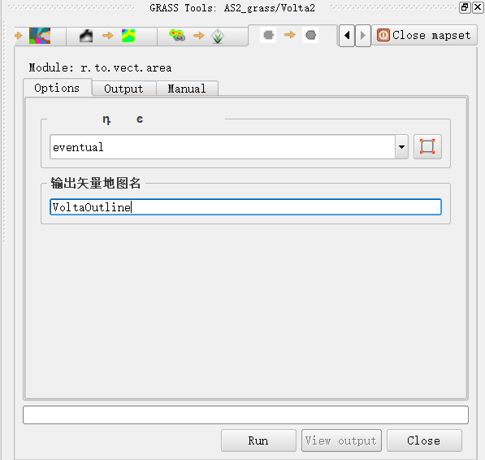

**Map:**

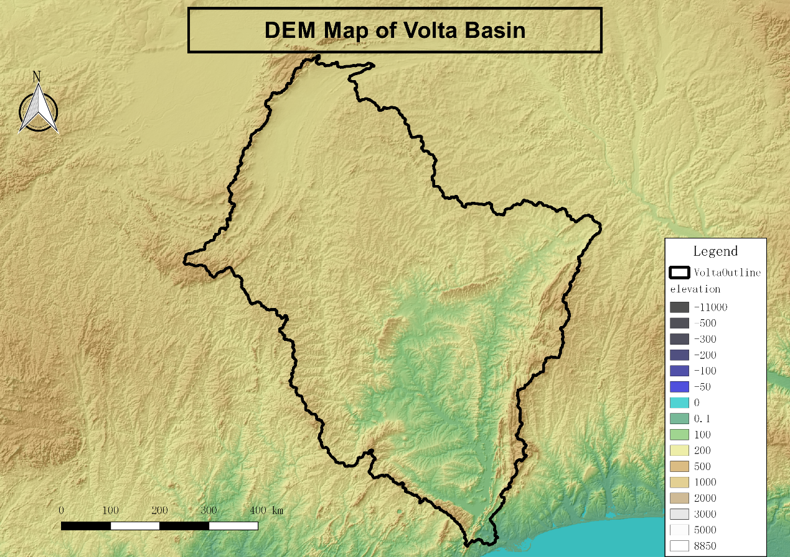

**Task 3. Outline the main Volta sub-basins**

1. To identify sub-basins inside Volta, three outlet points are pinned due to r.water.out method and each point stands for the sub-basin which is our focus.

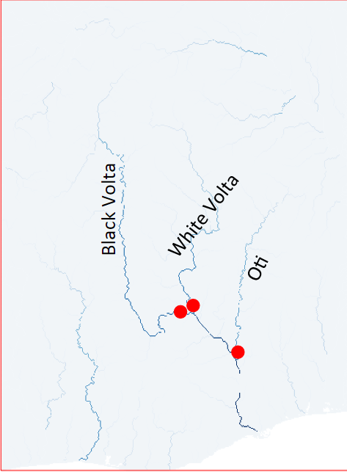 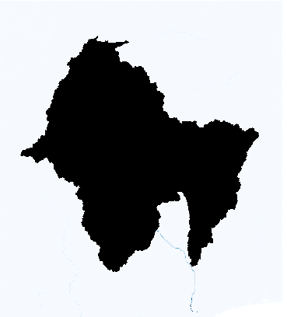

1. Convert generated sub-basins into vector data.

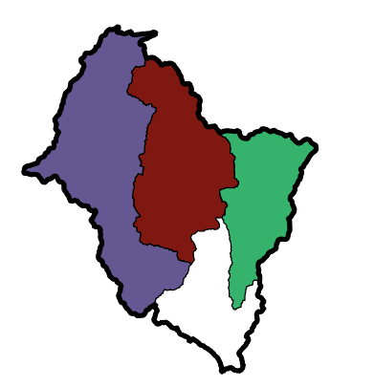

**Task 4. Stream**

1. Test out different thresholds that could affect the display of tributaries inside Volta Basin. Small tributaries are not included to make our map clean and concise.



|  |  |
| --- | --- |
|  |  |
| Threshold 10000 | Threshold 20000 |
|  |  |
| Threshold 30000 | Threshold 40000 |

We’ve tried large range of thresholds from 10000 to 40000. Apparently, tributaries are decreasing as threshold increases. Three main tributaries Black Volta, White Volta and Oti still remain.

In the end, threshold 20000 is determined by considering the trade-off between the length of main tributaries and concise of the map.

1. “thin” the stream raster by r.thin and convert to lines in vector.

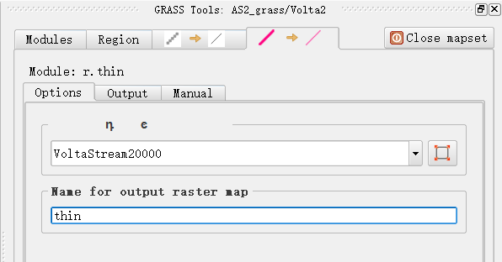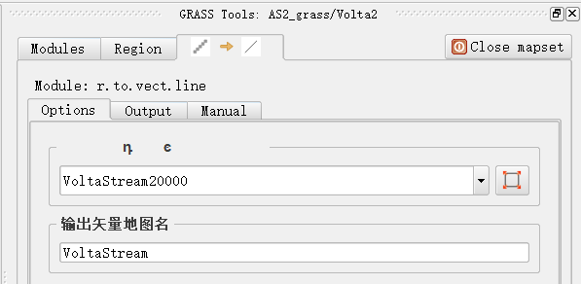

1. Intersect transformed stream line vector and Volta outline in order to clip unnecessary lines outside the boundary.

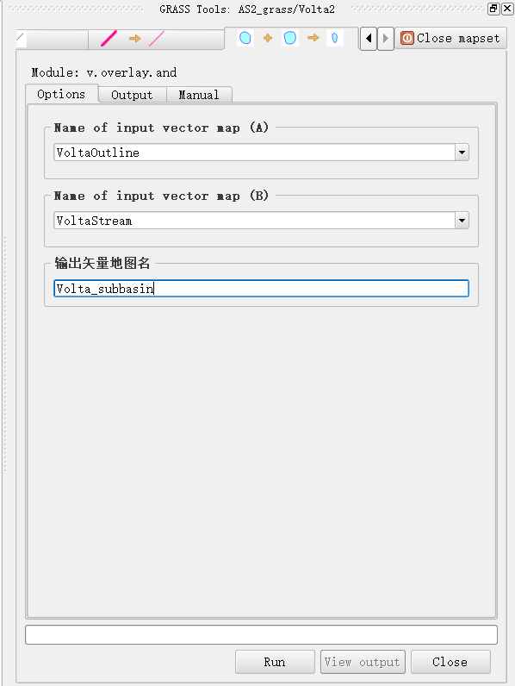

**Map:**

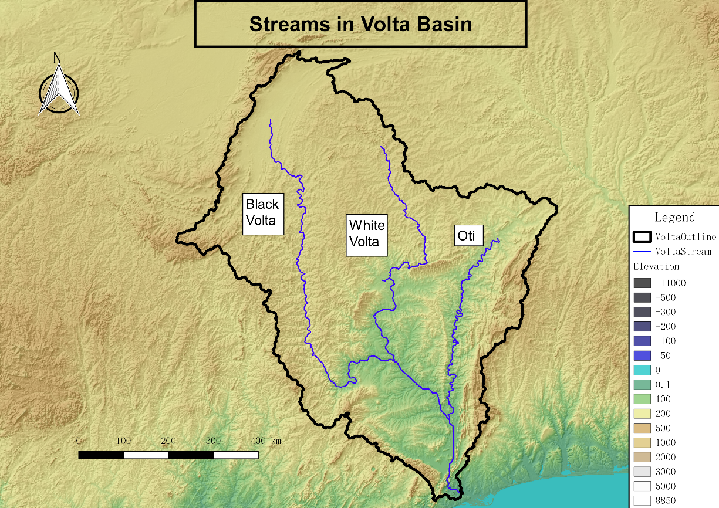

**Task 5. Include Lake Volta**

Lake is identified by r.Lake method which is defined according to coordinate (0.11deg E,7.63 deg N) and water level (80m).

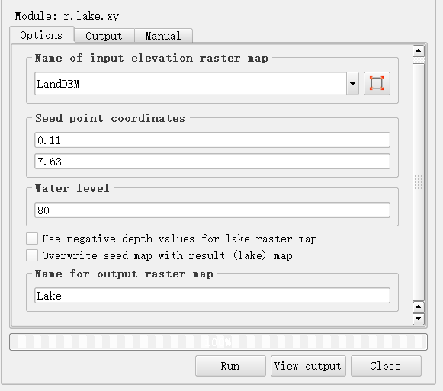

Raster calculator is used again to delineate the extent of the lake by typing such syntax into the shell.



**Ultimate Map:**

